**Lecture 04**

**NW4-IPClass-IP-Aliasing**

If “ping” is not successful, follow these steps,

* $ ping <web_address> 🡪 on base machine
* VM settings 🡪 network settings 🡪 Bridge adapter
* To check “interface” name $ ifconfig -a
* If the driver name is wrong in /etc/sysconfig/network-scripts/ifcfg-eth<>
* Than, rename it with $ mv command
* 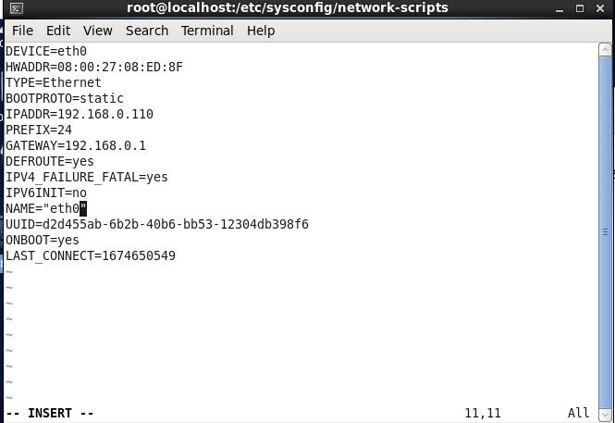
* In this pic I have added the DEVICE=eth0 , DNS1=8.8.8.8 🡪 DNS can also be added here (optional)
* And BOOTPROTO=dhcp 🡪 so that it can collect IP and GW automatically
* Than,
* $ ifdown eth0 🡪 so that the changes are saved
* $ ifup eth0 🡪 up and check ping
* $ ping google.com
* A screenshot of a computer

  Description automatically generated with medium confidence
* If by name websites are not assessable through “ping” edit “/etc/resolv.cnfg”
* And add free DNS or Default GW in it
* 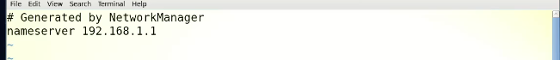
* **More troubleshooting steps.**
* Diagram

  Description automatically generated
* In CentOS 6 NM is beta version but in CentOS 7 its main HERO
* In CentOS 6 we need to stop NM and keep “network” on
* Command is
* $ service NetworkManager stop 🡪 to stop NM
* $ chkconfig NetworkManager off 🡪 it tells system no to start NM service after reboot
* Another way to stop NM is to config ifcfg-eth0 file and assign “no” to NM_CONTROLLED filed
* 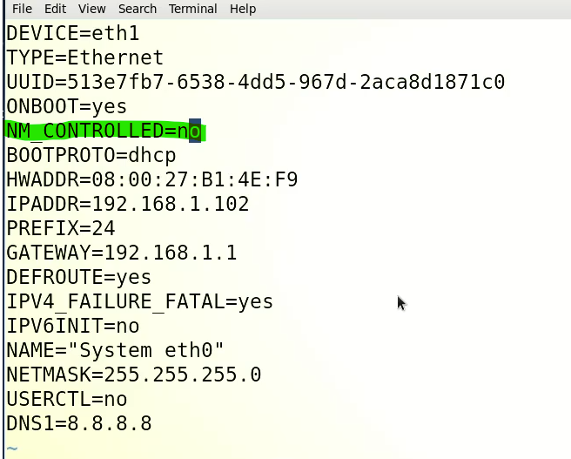
* Last troubleshooting step = interface name shown through “ifconfig -a” and in “ifcfg” file should be same
* i.e, DEVICE=eth0 and $ ifconfg 🡪 eth0
* 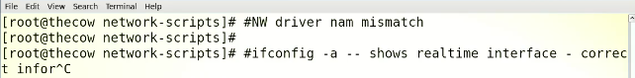
* Another step is to “comment out” hsrdware address or MAC address of the device in “ifcfg” file
* 
* Most of the issue will resolve with these steps.
* Configuration of network in RHEL 7/8 is different)

**Network classes**

* 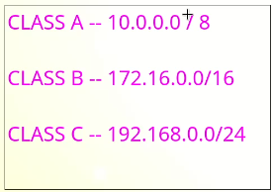
* **255.0.0.0 NETMASK**
* **255.255.0.0 NETMASK**
* **255.255.255.0 NETMASK**
* /8 or /16 or /24 is called 🡪 **“CIDER”** classless interdomain routing
* Tip:- the dot ”.” in IP addresses is called “octet” meants a group of 8 figures etc
* Class A is used in private networks
* If a company has 65000 computers than we will use Class C (private network) IP addreses
* If a company has lacks of computers than Class B IP will be used
* If a company has computer more than 1 caror than Class A IP will be used.
* Scenario
* If we have 10000 computers in a company and we want to assign IP to those computers,
* We will use Class C IP addresses

|  |  |  |  |
| --- | --- | --- | --- |
| 192 | 168 | 0 | 0  It is called Network |

We will assign Ips by this way

First machine will be assigned an IP

192.168.0.1

2nd

192.168.0.2

3rd

192.168.0.3

.

.

.

192.168.0.256 🡪 Till 256 machines

After that

192.168.1.1 🡪 for machine No. 257

192.168.1.2 🡪 machine No. 258

.

.

192.168.1.256 🡪 machine No. 512

....

.

.

.

192.168.2.1 🡪 Machine No. 513 … and so on

**0.0 or last 2 places in IP address are called “network” or “domain”**

* A company example,
* Technogeek.com and IP range (network) is 192.168.0.0
  + So rechnogheek.com = 192.168.0.0
* 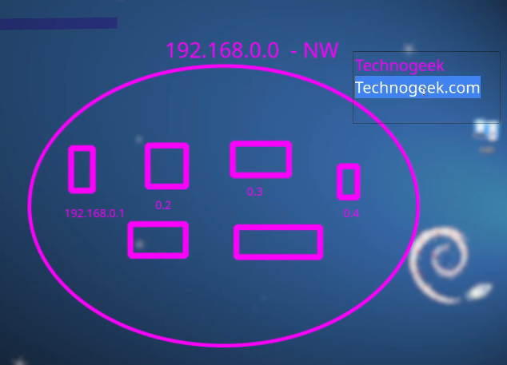

**IP aliasing**

* Adding additional IP address in Linux
* How to assign multiple IP addresses on an interface of a Network Card
  + We can assign 256 IPs on this interface or port
  + Icon

    Description automatically generated
* Driver (eth1) controls all the IP
* 
* Aliasing
* 
* But industry standard is to name “eth1” in a best understandable manner
* So,
* 
* Now $ ifconfig -a
* 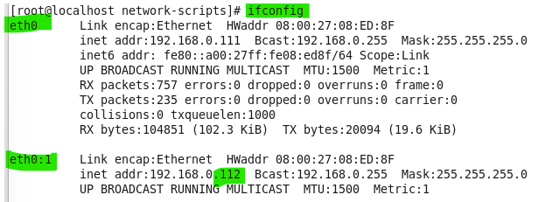
* * I used my machine which have driver name “eth0”
* Now “eth0” have another driver at it which is “eth0:1”
* This is called IP aliasing
* How to persist IP aliasing is query
* Solution

|  |
| --- |
| On Red Hat based systems, you can make IP aliasing persistent by adding the configuration to the network initialization script. Here are the steps to add an IP alias on Red Hat 7:   1. Open the network configuration file using a text editor: **sudo nano /etc/sysconfig/network-scripts/ifcfg-eth0** 2. Add the following lines to the file, replacing **IPADDR_ALIAS** and **NETMASK** with the desired IP address and netmask:   code  IPADDR_ALIAS0=IPADDR_ALIAS  NETMASK_ALIAS0=NETMASKALIAS0=IPADDR_ALIAS NETMASK_ALIAS0=NETMASK   1. Save the file and exit the editor. 2. Restart the network service: **sudo systemctl restart network**   This will add the IP alias and make it persistent across reboots. You can also use the ifconfig command to add the IP alias, but it will not persist across reboots.  You can also create a new file in **/etc/sysconfig/network-scripts/** directory, with the name **ifcfg-eth0:1** and put the IPADDR_ALIAS and NETMASK_ALIAS in that file. This will also make it persistent across reboots. |

* Two different classes of IPs (two networks) can communicate through IP aliasing 🡪 because it makes it possible to assign multiple IPs (different class IP) to a single interface
* 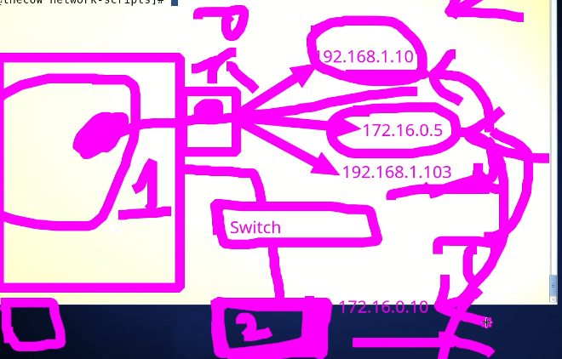
* The other solution is to use “router” to communicate two different networks.
* IP address tells the location which is being accessed. 🡪 used for finding location of the system.
* MAC ID is used for data communication.
* The driver manages the IPs i.e “eth0” or “eth1”
* 